3. File System Management
  - General
"On a Linux system, everything is a file; if something is not a file, it is a process."
A Linux system makes no difference between a file and a directory, since a directory is just a file containing names of other files. Programs, services, texts, images, and so forth, are all files. Input and output devices, and generally all devices, are considered to be files.
Most files are just files, called regular files; they contain normal data, for example text files, executable files or programs, input for or output from a program and so on. While it is reasonably safe to suppose that everything you encounter on a Linux system is a file, there are some exceptions:
(1)Directories: files that are lists of other files.
(2)Special files: the mechanism used for input and output. Most special files are in /dev, we will discuss them later.
(3)Links: a system to make a file or directory visible in multiple parts of the system's file tree. We will talk about links in detail.
(4)(Domain) sockets: a special file type, similar to TCP/IP sockets, providing inter-process networking protected by the file system's access control.
(5)Named pipes: act more or less like sockets and form a way for processes to communicate with each other, without using network socket semantics.

The command ls -l can displays the file type:
[root@localhost ~]# ls -l
total 76
-rw------- 1 root root 892 Feb 27 01:00 anaconda-ks.cfg
-rw------- 1 root root 8 Mar 5 22:51 dead.letter
drwxr-xr-x 2 root root 4096 Feb 26 17:17 Desktop
-rw-r--r-- 1 root root 26503 Feb 27 01:00 install.log
-rw-r--r-- 1 root root 3488 Feb 27 00:58 install.log.syslog
-rw------- 1 root root 11621 Mar 5 22:51 mbox

File type:
symbol | Meaning
- | Regular file
d | Directory
l | Link
c | Special file
s | Socket
p | Named pipe
b | Block device

  - File system structure
The Linux file system is usually thought of in a tree structure. The tree of the file system starts at the trunk or slash, indicated by a forward slash (/). This directory, containing all underlying directories and files, is also called the root directory or "the root" of the file system.

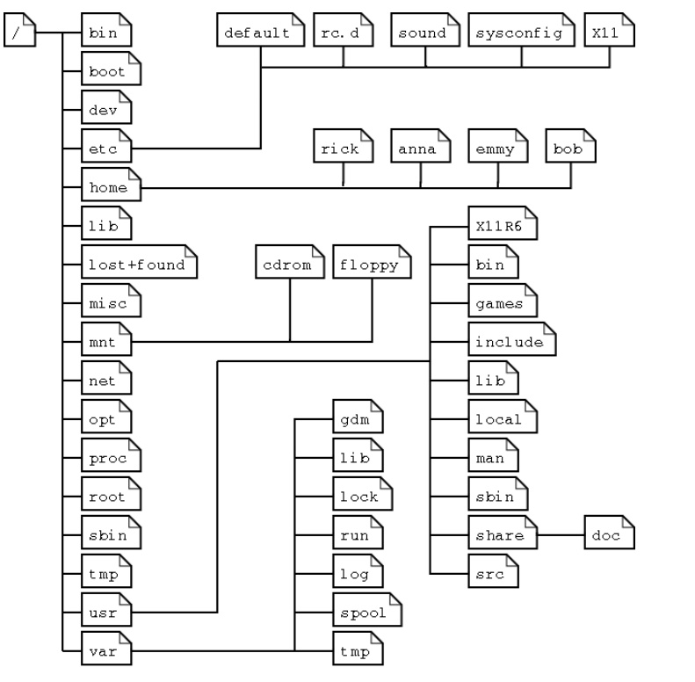
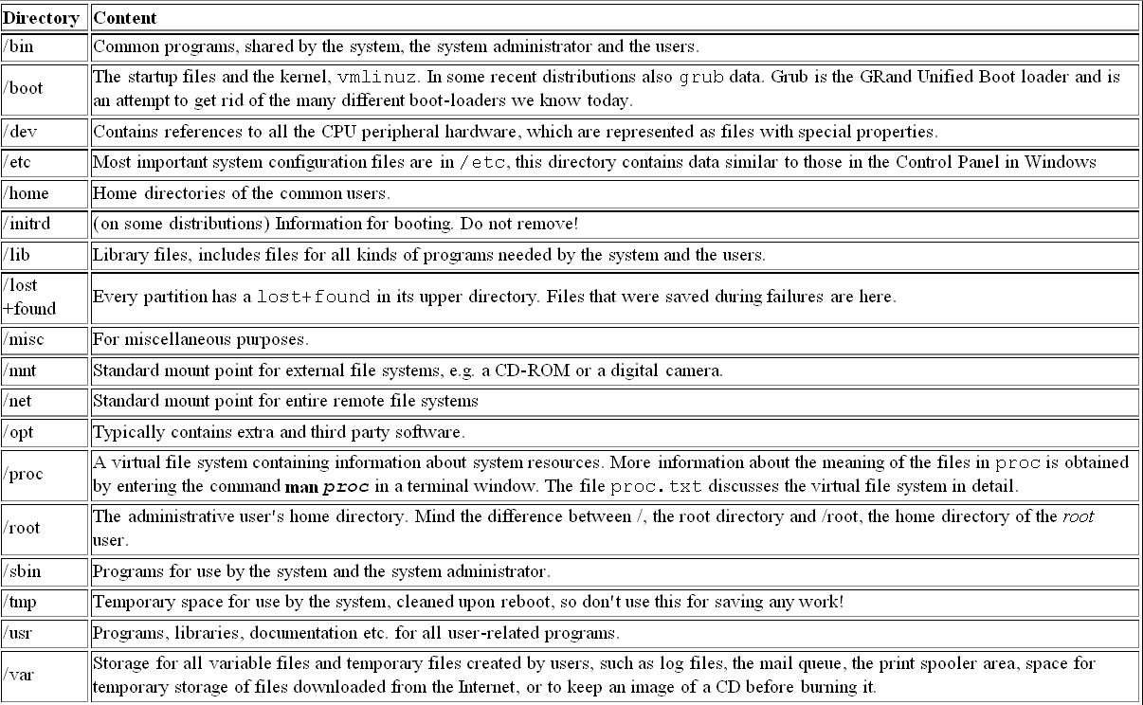
  - Home directory and current directory
- Home directory
Home directory is your first location in linux file system when you login the system successfully. In most cases it is a subdirectory of /home. For Example, if your account is tom , your home directory is /home/tom in most case. But for root, his home directory is /root.
- Current directory
When you first login the system, your location is in your home directory. You can change your location in file system by “cd” command. Your current location is current directory. Your current directory may be the same as your home directory , may be not. It depends on where you are in the file system now . For example , if you are in /etc directory, your current directory is /etc
In linux , . refers to current directory and .. refers to your upper directory or parent directory.

3.4 Absolute path and relative path
A path is the way you need to follow in the tree structure to reach a given file. It can be described by absolute path and relative path.

1. Absolute path
If the path starts with a slash and is called an absolute path, the path is absolute path. For example, /etc/inittab

2. Relative path
If the path doesn’t starts with a slash, it is a relative path. In most cases , relative path starts with your current directory . For example, if your current directory is /tmp , the relative path to /etc/inittab is ../etc/innittab

  - File system command
The basic command
 | command | Description | Example
1 | Ls | List file or directory information | ls; ls –a ; ls /etc, ls Radio
2 | mkdir | Create directory | mkdir music; mkdir –p music/pop ; mkdir /tmp/abc
3 | cd | Change current directory | cd music cd /tmp/abc
4 | pwd | List current directory | pwd
5 | rmdir | Remove directory( this directory must be empty) | rmdir music; rmdir /tmp/abc
6 | touch | Create a new empty file or upate the date of a existing file. | touch file1
7 | Rm | Remove file | rm file1 ; rm radio/rain.mp3, rm /tmp/file2
8 | cp | copy file or directory | cp file1 file2, cp /tmp/file1 /usr  cp –r /home/user1 /tmp
9 | cat | view text file content | cat file1
10 | more | view text file content | more file1
11 | Less | view text file content | less file1
12 | head | print the first 10 lines of file | head file1
13 | Tail | Print the last 10 lines of file | tail file1
14 | Mv | Move file or change name of file or directory | mv file1 file2 , mv file1 /tmp
15 | which | Look in the directories listed in the user's search path for the required file | which ls
16 | find | Find file in file system | find /usr -name "*.tmp"  find / -name "*.tmp" -exec rm {}
17 | slocate | Find file in a file indexed database | slocate ls
18 | Tar | Compress and uncompress file and directory | tar –cjf user1.tar.bz2 /home/user1  tar -czf user1.tar.gz /home/user1  tar –xjf user1.tar.bz2  tar –czf user1.tar.gz

  - Exercise
- create directory /home/test1 ,/root/test2
- change current directory to /home/test1
- list current directory
- show all files(including hidden files) in the current directory
- create file1 in /home/test1
- copy file1 to /root/test2
- delete file1
- delete /home/test1
- rename file2 in /root/test2 to file3

